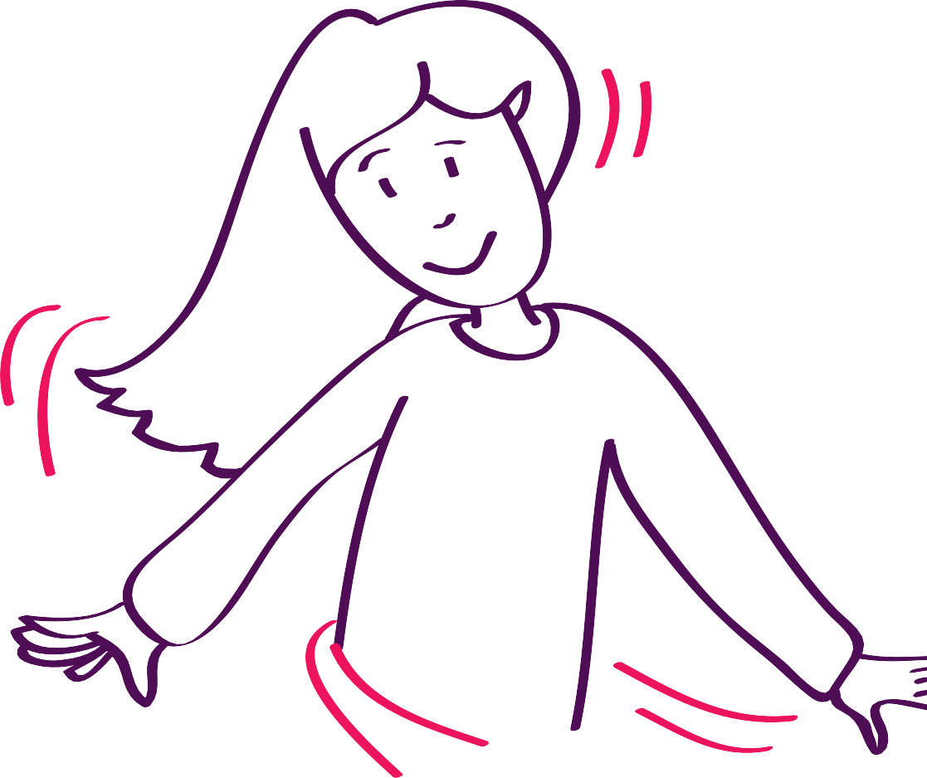
Autism seminars for families

Sensory needs
Seminar booklet

Autism seminars for families

Sensory needs

Seminar booklet

Published in 2017 by The National Autistic Society 393 City Road, London EC1V 1NG www.autism.org.uk
All rights reserved. No part of this book can be reproduced, stored in a retrievable system or transmitted, in any form or by means electronic, mechanical, photocopying, recording or otherwise without the prior permission of the copyright owner.

Copyright © The National Autistic Society 2017 ISBN 978-1-910707-08-1
Illustrations by Claire Lythgoe

With thanks to the Morrisons Foundation for their support.

Autism seminars for families

Sensory needs

Seminar booklet

This seminar booklet is designed to accompany the
Sensory needs seminar.

A range of people deliver this seminar, including National Autistic Society employees and professionals who have bought our facilitator pack. The materials
in the pack, including the presentation and seminar booklets, have all been written and developed by The National Autistic Society.

The seminars and booklets are based on the highly successful help! programme The National Autistic Society developed in 2002.

This seminar you are attending today is being delivered by:

Language used to describe autism
Our most recent research into the language we use to describe autism showed there is no single term that everyone prefers. Although it does suggest a shift towards more positive and assertive language,
particularly among autistic communities, we recognise that many parents prefer ‘person-first’ language
such as ‘child with autism’ and ‘child on the autism spectrum’. Therefore we have used these terms throughout this booklet.

For more information on the research, visit

www.autism.org.uk/describingautism.

Contents
Sensory processing 3 Sensory processing differences in children with autism 5 Helping your child with their sensory needs 20 Useful reading 29

Sensory processing

The seven sensory systems
Touch (tactile)
The tactile system provides information about the environment, objects and textures around us. This includes information such as whether things are hard, soft, sharp, dull, hot, cold or painful to the touch. The sensory receptor for this system is the skin. Some areas of skin are more sensitive than others.

Sight (visual)
The visual system provides information about objects and people around us. It helps us to define boundaries as we move through time and space. The sensory receptor for this system is the retina in the eye.

Hearing (auditory)
The auditory system provides information about whether sounds in the environment are loud, soft, high, low, near or far. The sensory receptor for this system is the inner ear.

Smell (olfactory)
The olfactory system provides information about different types of smell, such as musty, acrid, putrid, flowery and pungent. The receptors for this system are the chemical receptors in the nose.

Taste (gustatory)
The gustatory system provides information about different types of taste, such as sweet, sour, bitter, salty and spicy. The sensory receptors are the chemical receptors on the tongue and throat.

Balance (vestibular)
The vestibular system provides information about movement, gravity and changing head positions. It helps us know where our body is in space and whether or not we or our surroundings are moving. Even without vision we are able to tell without looking if we are horizontal or vertical (however visual information
is very important for this system). The receptor for this system is the inner ear.

Body spatial awareness (proprioception)
The proprioceptive system provides information about which parts of our body are moving and how. It allows us to control movements without looking. It is also involved in the amount of pressure needed to manipulate objects. The sensory receptors are in the muscles, joints and tendons.

Sensory processing

- Our bodies and the environment send our brains information through the senses.
- We process and organise this information so that we feel comfortable and secure.
- This helps us to understand the world and respond appropriately.

To enable us to make sense of the world around us, our brain processes all the sensory information we receive through all the different systems. It helps us to organise, prioritise and understand the information. By doing this we do not become overloaded and can respond appropriately.

We then respond to this sensory information through thoughts, feelings, behaviour or a combination of these.

Most of the time, we process sensory information automatically without needing to think about it much.

You may hear different terms to explain this. Often the terms ‘sensory processing’ and ‘sensory integration’ are used interchangeably. Throughout this booklet we will use the term ‘sensory processing’.

To understand sensory processing, it is important to look at the different stages that happen from receiving sensory information to acting on it.

Receive
This is the stage where we become aware of some sensory input (registration), and then we pay attention to it (orientation).

eg “I feel something on my hand” or “I can hear something”.

The level at which we register and pay attention to sensory information may vary throughout the day, depending on our previous sensory experiences or how alert or stressed we are. For example, in the middle of the day our brain may not register the noise of the stairs creaking, but it may do in the middle of the night.

Process
This is the stage where we try to make sense of the sensory input to work out what to respond to and whether it is threatening (interpretation). Then we can begin to work out what kind of response is actually needed (organisation).

eg “The plate in my hand is very hot, this may hurt me, I need to put it down” or “That’s the sound of the doorbell, I’d better go and answer it”.

We will often use our past experiences to help us with this, comparing new sensory experiences with old ones. Our nervous system is designed to respond to sensory input to protect us from harm, known as the ‘fright, flight or fight’ reaction. If sensory input triggers this reaction, our heart rate and breathing will increase, putting our bodies in a high state of alert.

Respond
This is the stage where we carry out any response that we have decided is necessary (execution).

eg “Put the plate down” or “Walk over to the door and open it”.

The response that we make can be an action, a thought or an emotion. This could include a response of ‘doing nothing’. If the response is an action (motor response), our brain receives new information about body movements and touch and the cycle of sensory processing begins again.

Make a note
Look at the scenario you’ve been given and discuss: What sensory systems do you think are involved?

Sensory processing differences in children with autism

Make a note
Watch the A is for Autism DVD. Note any similarities or differences from your own child’s sensory experiences.

Sensory differences are not exclusive to autistic people and not every behavioural difficulty is about sensory issues. It is, however, an important area to look at when helping your child to feel comfortable and secure.
What might it feel like?
- Turn on the radio but don’t tune it – leave it on static and fuzz.
- Try to sit on a one-legged stool.
- Sit at a table that is wobbly.
- Put on a scratchy shirt.
- Wear shoes one size too small.
- Eat a meal of sardines and coffee granules.

Now pick up a text book and try to learn a new skill.

These differences could mean your child finds some things incredibly difficult or distressing, but there may be other things that they get very enthusiastic about and enjoy.

Common differences
Sensory processing difficulties are increasingly seen as a common difference experienced by children on the autism spectrum, and may happen at any of the sensory processing stages.

You may hear these terms used to describe these differences:
- Sensory Processing Disorder or Dysfunction
- Sensory Integration Disorder or Dysfunction.
eg A child may love spinning, playing with water, listening to the wind whistling through the trees or looking at raindrops resting on leaves.

Most of us learn unconsciously to integrate our senses to make sense of our environment. However, many autistic people have difficulties with this.

Some common difficulties in children with autism that process sensory information differently are as follows:

Over-sensitivity or under-sensitivity
Children can be either over-sensitive (hypersensitive) or under-sensitive (hyposensitive) to a variety of sensory inputs. These responses can be inconsistent and can vary on a daily basis.

If a child is over-sensitive, their brain may be telling them to pay more attention to a particular sensory input and they may be processing this input as being very intense.

eg They may hear sounds from very far away, a light may seem overly bright to them or they can feel a tiny seam in their clothing.

As a result of being over-sensitive they may try to avoid certain sensations.

If a child is under-sensitive, their brain may not be registering or paying attention to certain sensory input, so they may not show typical reactions that other people would expect.

eg They may not notice their clothes are twisted on their body, may not show much awareness of pain or may not get dizzy when spinning around.

As a result of being under-sensitive, they may try to seek certain sensations.

Some children who appear to be under-sensitive may actually be experiencing ‘shutdown’. This is where they are feeling so overwhelmed by incoming sensory information that they shut down completely to protect themselves.

Filtering sensory information
Children may have difficulties with knowing which information to pay attention to and which to ignore. There is sensory input around us all the time and part of the role of sensory processing is to determine which input we need to pay active attention to and which
to ignore. If someone has difficulties with filtering the vast amount of sensory input coming in, this can lead to them not paying attention to the right things and experiencing ‘sensory overload’.

eg All the sounds around a child may seem to be at the same level, making it difficult for them to pick out the teacher’s voice and pay attention to him or her. Or a child may be getting sensory input about how their clothes feel on their body as well as trying to watch the TV (typical processing would filter out this information as you don’t need to attend to it to watch TV).

Level of arousal or alertness
The brain tries to make sure we are at the right level of arousal or alertness for what we are trying to do. This process is called sensory modulation and our level of arousal varies throughout the day.

eg We might drink coffee in the morning to wake us up and make us feel more alert. A child might fiddle with a pen to help them concentrate. We might turn the light down low to help us relax in the evening.
Many children with autism have difficulty being at the right level of arousal for the situation they are in. This can lead to them having difficulties with paying attention, controlling their impulses and coping with frustration, and they may show extreme emotional reactions.

eg It takes a child with autism a lot longer to calm down after playtime than another child without autism, or it is very difficult to get the child motivated in the morning.

Sensory defensiveness
This term refers to some children’s tendency to react negatively or with fear to sensory input that is generally considered inoffensive to the majority of others.

eg Covering their ears when they hear a certain noise, gagging if they look at a particular food, or feeling extreme fear of falling if they have to close their eyes when in the shower or if their feet can’t touch the floor when on the toilet.

Children may be defensive in just one sense or in a variety of senses, and their level of defensiveness can vary greatly.

One sensory input at a time
Children with autism may find it difficult to pay attention to input from more than one sensory channel at a time.

eg If they are listening to you they may not be able to look at you.

Attaching a meaning to a sensation
Many children with autism find it difficult to link back to past experiences, and this makes it very difficult when they are trying to make sense of sensory input.

eg “The cooker was hot last time I touched it, better not touch it again!”

A child who cannot tell whether water is hot or cold, or doesn’t recognise the feeling when they need to go to the toilet.

Common differences in individual senses
There are some difficulties which might be specific to processing differences in the individual senses. The following pages show examples of some of these, and have space where you can write down any other examples you can think of for your child.

Touch
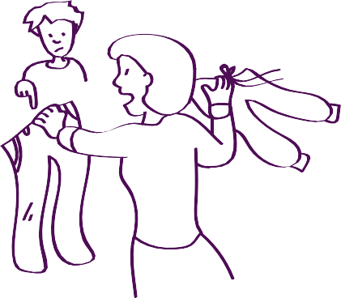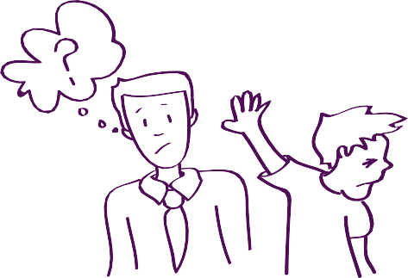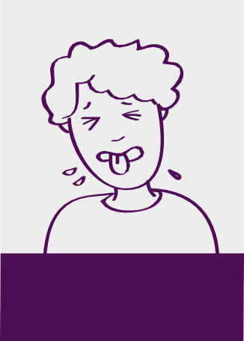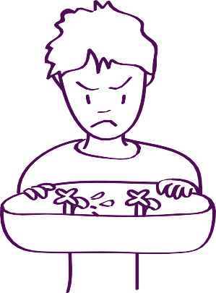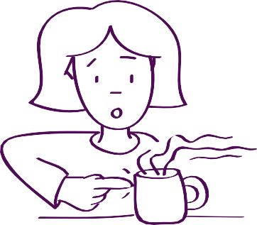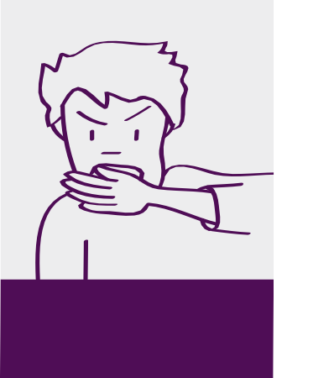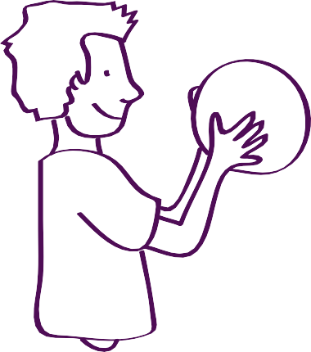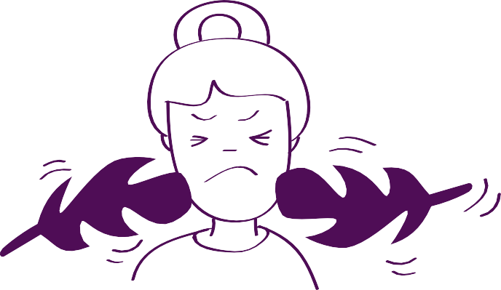
Might only be able to tolerate certain clothing
Dislikes or seeks touch from people or objects

Gags at different food textures, has a very restricted diet
These are examples of different behaviours you may see
Avoids personal hygiene activities
Different or delayed reaction to pain or temperature

Bangs head or bites hand (self-injurious behaviour)
Is constantly touching things, always needs to be holding something
May prefer deep pressure to light touch

Make a note
Does your child have any other sensory processing differences with their tactile system?

Sight
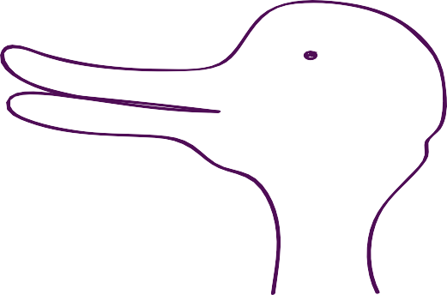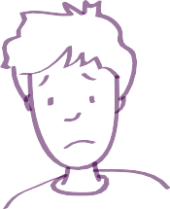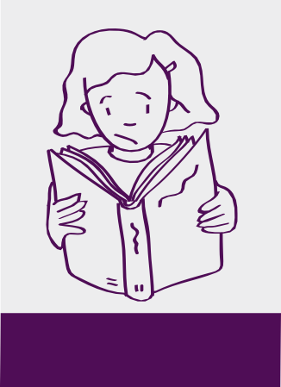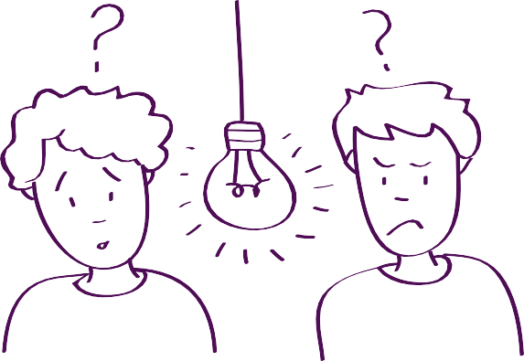
What can you see?
This picture (right) is an ambiguous figure in which the brain switches between seeing a rabbit and a duck.
The duck-rabbit was originally noted by American psychologist Joseph Jastrow. The eye and brain make an unconscious inference about the meaning of the picture. As the picture is ambiguous, the brain switches between the two pictures.
These are examples of different behaviours you may see
Difficulty in tracking movement
Uses peripheral rather than central vision

Problems with reading and writing
Distorted vision
Sensitivity or distraction caused by lights, colours or patterns

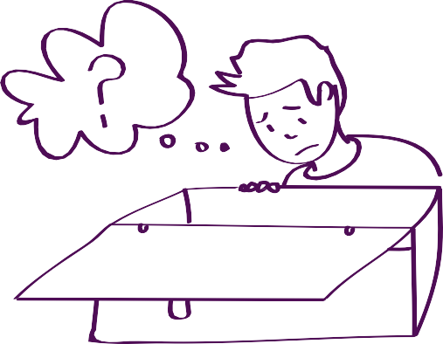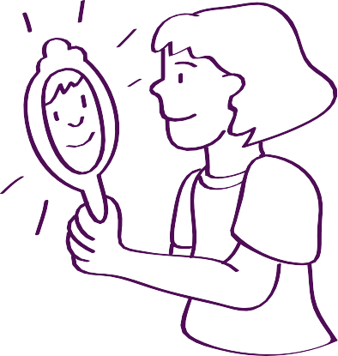
Can have difficulty with finding things
Seeks out shiny surfaces and reflections
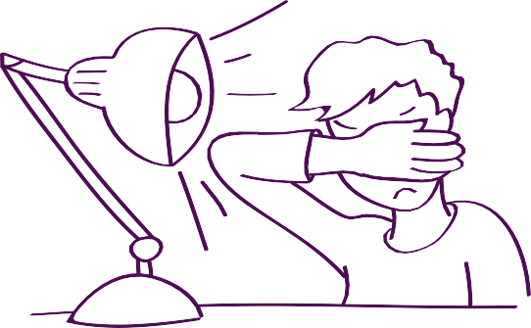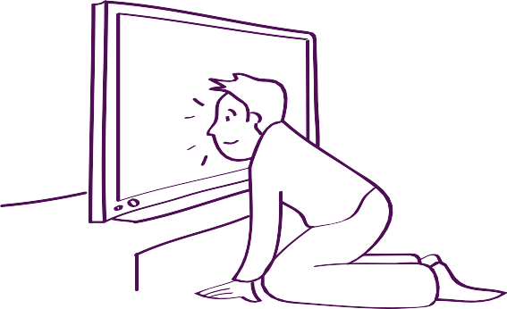
Dislikes bright lights or sunlight
Puts head close to TV or dinner plate
Make a note
Does your child have any other sensory processing differences with their visual system?

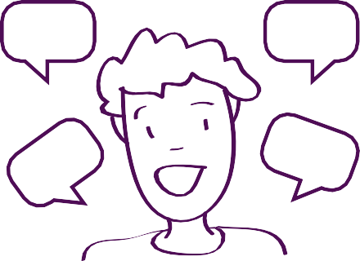Hearing
Likes certain sounds and repeats them frequently
Beep!
Beep!
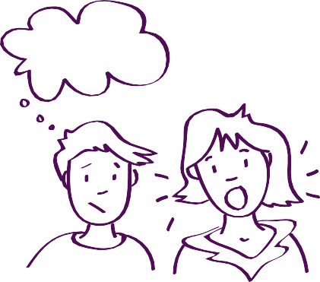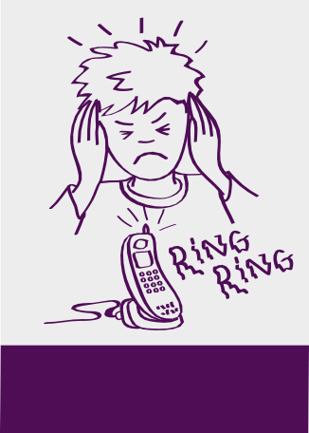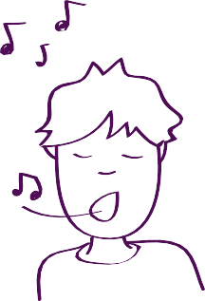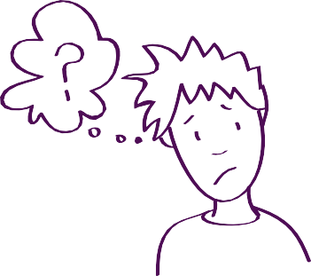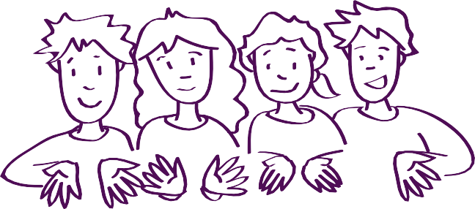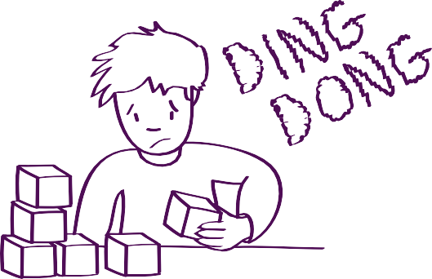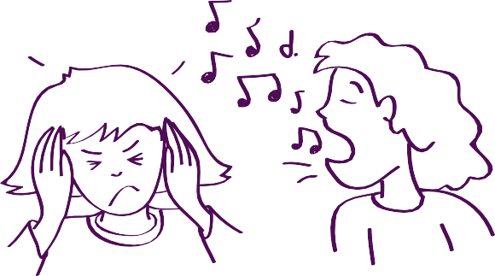
Talks loudly
When?
harumph

Finds some sounds distressing or distorted
These are examples of different behaviours you may see
Hums or sings to block out other noises
Enjoys or tries to avoid crowded and noisy places
Finds it difficult to block out background noise and struggles to concentrate
Gets annoyed when other people are talking, singing or eating

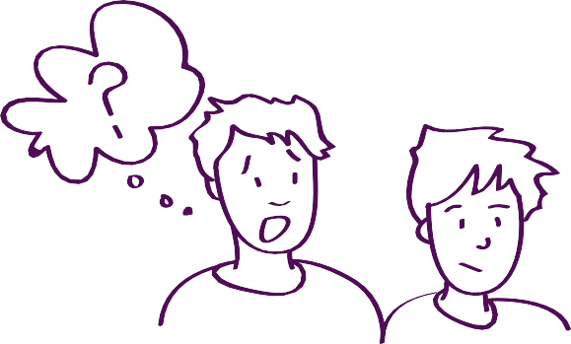
Doesn’t respond to voices

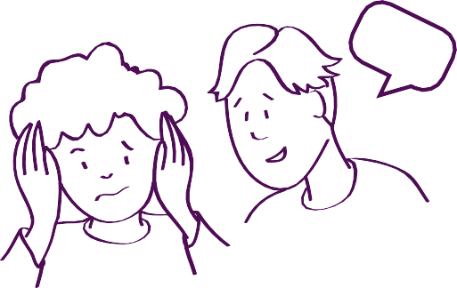Make a note
Might be sensitive to, or not able to register, certain sounds
Does your child have any other sensory processing differences with their auditory system?

Smell and taste
The smell and taste senses are very closely linked which is why we look at them together.
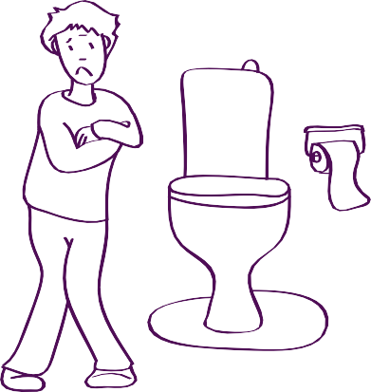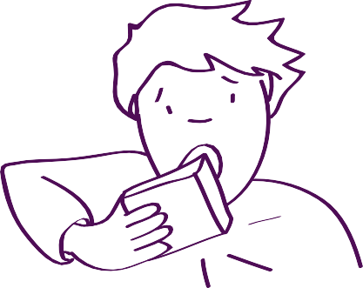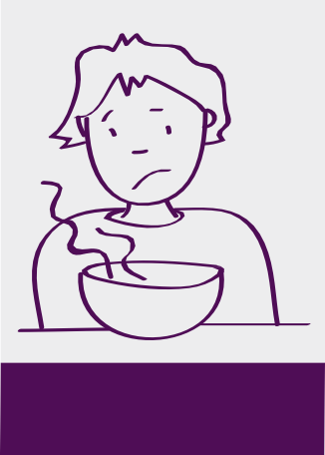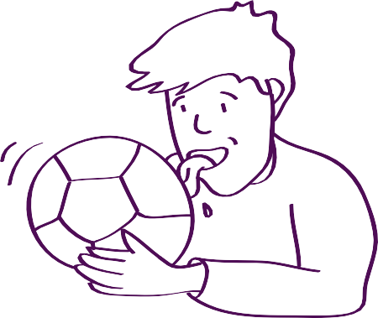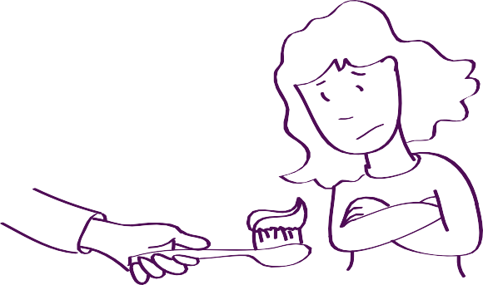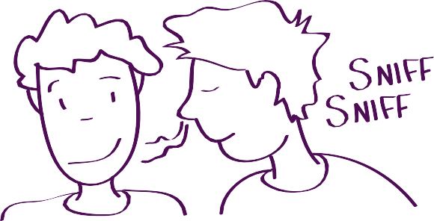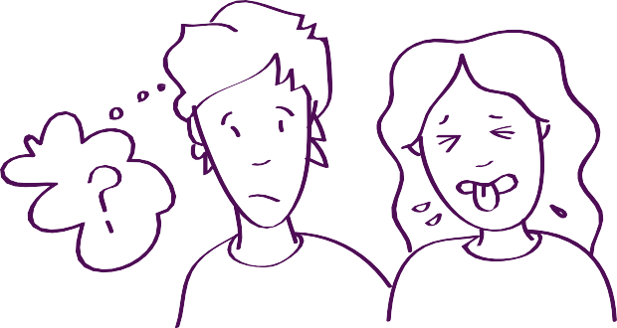
May have difficulties with using the toilet or bathroom
Eats non-edible items (pica)

Prefers or avoids certain foods or smells
These are examples of different behaviours you may see
Licks people or objects
Refuses to use toothpaste
May use smell to recognise certain people
Not able to tolerate certain food tastes, smells or textures

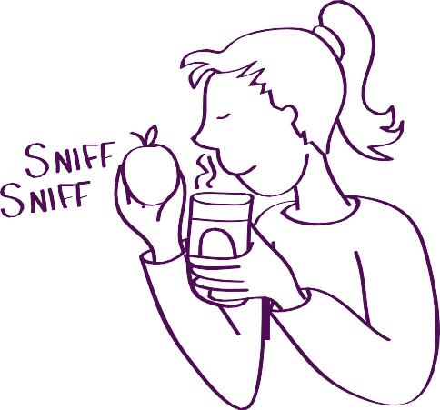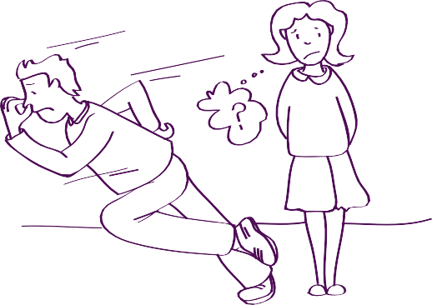
Sniffs everything
Difficulty with changing smells around school

Make a note
Does your child have any other sensory processing differences with their olfactory and gustatory systems?

Balance
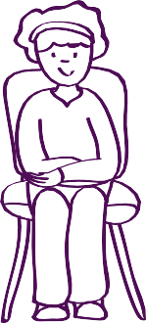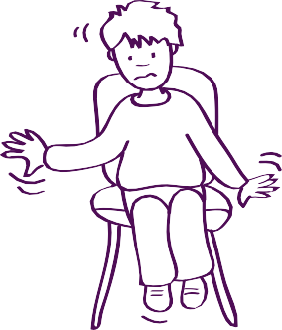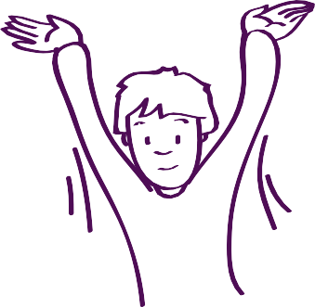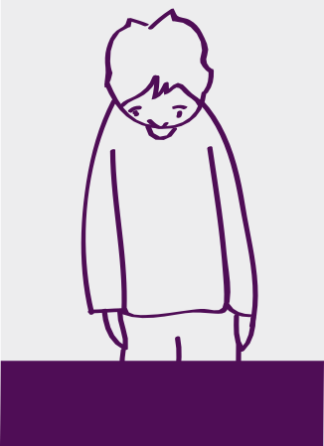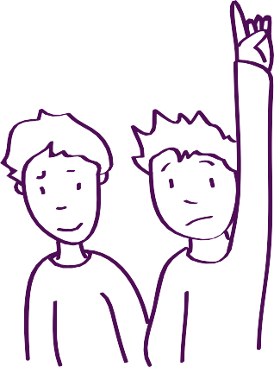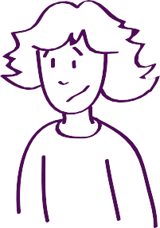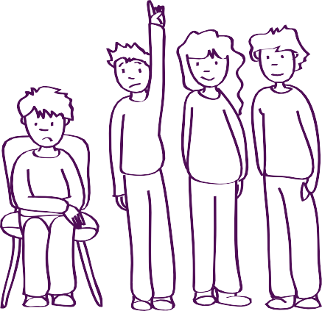
What can you see?
Fairground ride – Many of us may have enjoyed going on fairground rides as children, but as adults find we are unable to do so anymore. Our need for movement may change as we get older, hence we may react differently to fairground rides.

Treadmill – Many adults who go on a treadmill find that unless they slow it down very gradually, it feels like they are still moving when it comes to a stop. This could be because their vestibular system is still predicting the movement.
These are examples of different behaviours you may see
Difficulties with activities where the head is not upright or feet are off the ground
May avoid or actively seek out movement

Needs frequent movement breaks
Difficulty staying in the same position
Gets tired easily

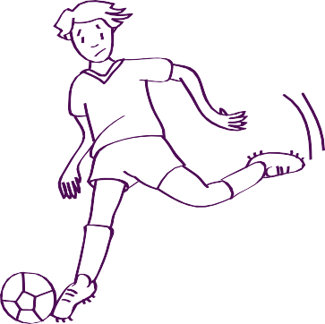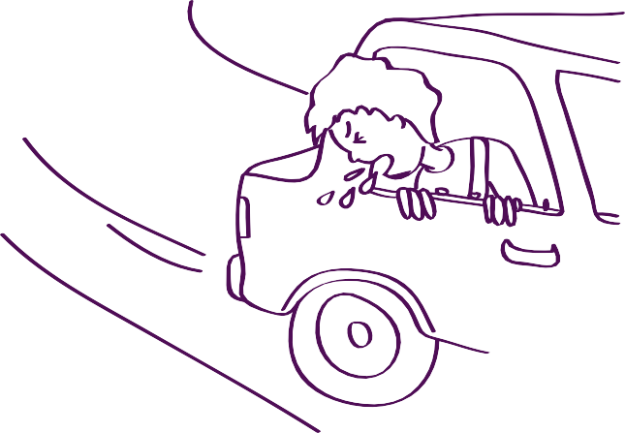
May find sport and games difficult
Feels sick in cars or buses
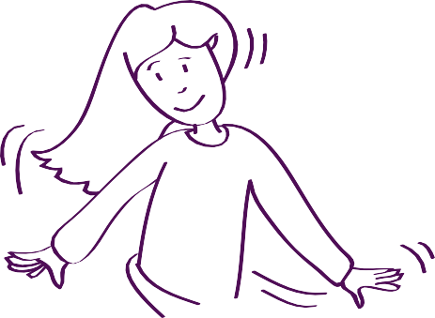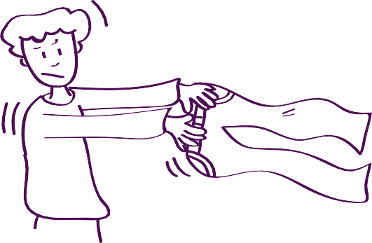
May rock, spin or swing
Finds it hard to keep balance when dressing or getting in the bath
Make a note
Does your child have any other sensory processing differences with their vestibular system?

Body spatial awareness
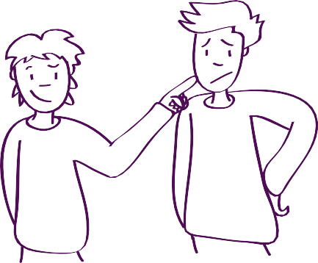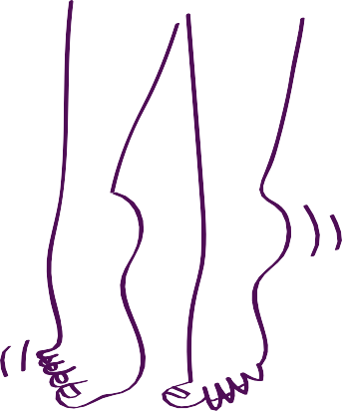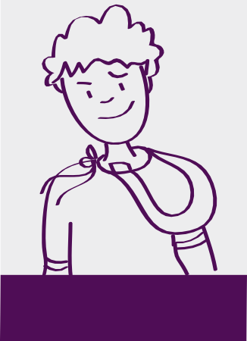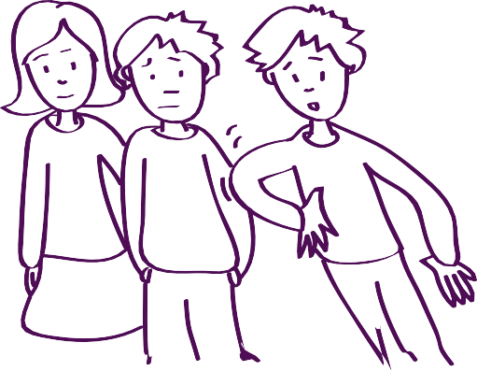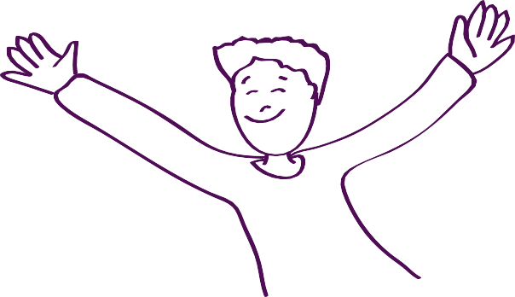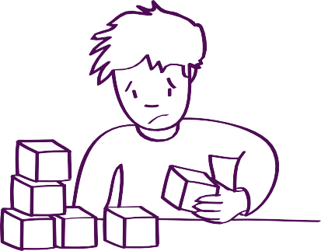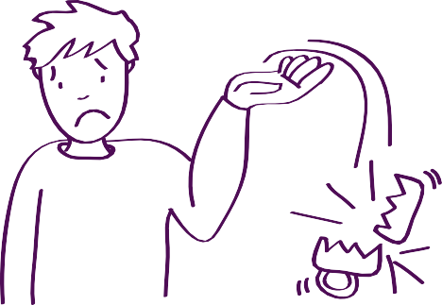
Not being aware of body sensations
Walks on tip toes

Doesn’t notice clothing twisted on body
These are examples of different behaviours you may see
Bumps or leans into people or objects
Limited body spatial awareness
Difficulties with fine motor activities
May drop or break objects

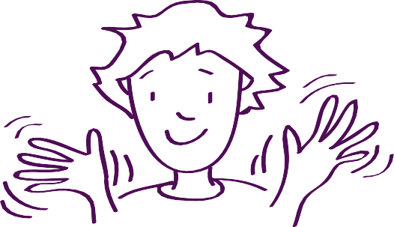
Turns whole body to look at you
Flaps hands
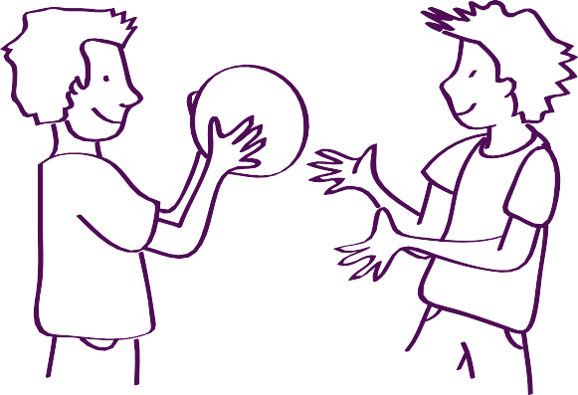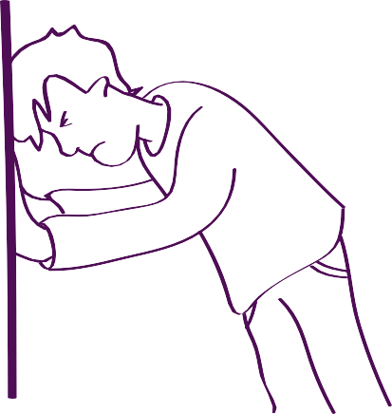
Enjoys rough and tumble play and sports
Bangs head or bites hand
Make a note
Does your child have any other sensory processing differences with their proprioceptive system?

Sensory worksheet

Is there an activity or situation your child finds difficult?

 | Possible sensory reasons Why? | Potential strategies How?
Touch
Sight
Hearing
Smell
Taste
Balance
Body spatial awareness

Helping your child with their sensory needs
There are a variety of things you can do to try to help your child with their sensory needs. You may find that you need to do a mixture of things and try different things on different days. The important thing to remember is that your child may be processing sensory information very differently and that this can vary on a daily basis.

Make a note
Look at the items you’ve been given and discuss how these might help with a child’s sensory processing differences.

Note down any other items that might be useful.

General strategies

Be the detective
It can be useful to try to understand why a behaviour might be happening, as this might give you some clues as to what might help reduce or eliminate it. It is important to try to think from the child’s perspective why they might be behaving in a particular way, along with considering if the behaviour is actually a problem, or is it something they can continue if they need to.

Avoid the situation
There may be some sensory experiences that are uncomfortable, distressing or painful for your child. Supporting or teaching them to avoid that sensory input may be useful. This may be for a short period of time while you try to teach them to cope with it, or it might be a long-term strategy. This will depend on the type of sensory input it is.

eg We can avoid eating bananas, but a child can’t avoid going in all shops for the rest of their life.

Desensitise
Desensitisation refers to a process of gradually getting someone used to a sensation or experience that they previously had a fearful or extreme reaction to.

We might first try helping them to avoid the parts of a situation that they find difficult and just experience a short amount of it.

eg Only going to the shop when it will be quiet; just going into the last five minutes of a long school assembly; or wearing headphones to reduce noise.

eg Initially only flushing the toilet when the child is out of the bathroom, then gradually flushing it when they are a bit closer.

eg Visiting small shops for very small amounts of time before gradually building up to visiting bigger shops for longer periods.

Many children with autism are extremely sensitive to certain sensory input. This may be because they
have not been able to receive, or allowed themselves exposure to, a particular input, so their sensory receptors are still very sensitive.

eg When babies are born, their mouths are highly sensitive. It is only through the process of drinking and eating that they gradually become desensitised. For some children with autism who have a restricted diet, the inside of their mouth may still feel very sensitive.
With any form of desensitisation, it is very important to take it slowly, and you may need to combine it with visual supports to show the child how long they have to cope with the sensory input.

eg If you’re trying to get a child to wear new shoes, try using a timer that shows how long they have to keep them on for.

Some children may have highly sensitive reactions when we try to begin an activity with them, so allowing them time to get used to the sensation may be helpful.

eg Touching their fingers firmly to reduce their sensitivity to touch before beginning to trim their nails, or firmly touching their head before brushing their hair.

Communication strategies
With some children, it is helpful to try to give them a means to communicate when they are looking for or trying to avoid a particular sensory input. Because of their difficulties with understanding other people’s perspectives, many children with autism may not realise that their experiences are different from other people’s. Using visual supports can often help
with this.

eg A symbol that your child can use to tell you they’ve had enough and need to leave, or a phrase that they can use to explain that they can’t cope with something.

Empower the child
Some sensory input is easier to cope with if it is under our own control. By allowing or encouraging your child to control how much sensory input they receive, it may increase their ability to cope.

eg Letting your child brush their hair or clean their teeth, or letting them use headphones to block out sound when they need to.

Provide structure
Children with autism often cope better when they know what is happening, in what order and for how long. If we can give them structure so things become more predictable, it may help with sensory processing differences.

eg Teeth cleaning always happens at a certain time for a certain length of time, or going on the trampoline always happens when they come home from school.

Mixture of sensory input

A mixture of sensory input can help a child’s nervous system to feel better organised and support the child’s attention and performance. This is paramount for
the child to be a successful learner. Although this is important for everyone, it is even more important for people with sensory processing differences, because they are sometimes unable to modulate or self-regulate their sensory input.

Calming activities
Providing a variety of calming activities or items can help with relaxing the nervous system, with the aim of helping to reduce anxiety, sensory defensiveness and ‘fright, flight or fight’ reactions.

Create a calm, ‘low arousal’ environment, especially in your child’s bedroom. Low arousal means approaching children and their environment in a calm and ordered way to reduce anxiety and help concentration.

There should be as few distractions as possible. Remove clutter as it often causes anxiety. Some children benefit from having plain, pale curtains, carpets and walls. By starting with a calm, uncluttered environment, you can then introduce other things that help your child.

Below are some suggestions for calming activities
- but remember that what might be calming for one child might be alerting for another:
- soft lighting
- deep pressure massage
- sleeping bags
- blankets, cushions, body pillows
- bean bags
- rocking chair
- weighted lap pads
- Lycra clothing
- quiet corner with sensory items
- low level lighting
- pop up tent or quiet corner
- sensory toys or fidget toys
- quiet music or white noise
- lavender or soothing smells.

Alerting activities
Activities that help with alerting are useful for children who have difficulties with being at the right level of arousal and who are hypo (under) sensitive. If your child is not responding to sensory input because they are experiencing sensory overload, these activities will not help.

Try introducing alerting activities for short spaces of time to start with. Some children can easily become over-stimulated if they do them for too long.

Below are some suggestions for alerting activities:
- running or games with running
- brisk walk
- trampoline
- swinging
- messy play
- catch or bouncing games
- bright lighting
- loud, fast music
- sensory toys or fidget toys
- strong smells
- tickling.

Organising activities
Some children seem to go very quickly between being over- and under-sensitive. Using the activities suggested below may help them to feel at the right level and to become more focused and attentive:
- sitting on a physio ball
- wheelbarrow walks
- pulling or pushing heavy objects
- heavy exercise
- pushing (against wall or hands together)
- sucking through straws
- chewing or blowing
- swimming
- vibrating pillows or massagers
- sensory toys or fidget toys
- strong smells
- tickling
- massage or joint compressions
- rhythmic activities.

Daily events | Activities
Morning | Alarm clock with light that gradually gets brighter.  Shower with strong-smelling shower gel and rub dry with towel.
Arrival at school | Encourage to look at visual planner to know what is happening.  Fiddle toy or blu-tack to help concentration.
Mid-morning | Run-around activity at break time, including putting-away task at end to help with winding down. Lap pad as reminder that it is work time again.
Lunch | Free-play choice from assortment of tactile activities, eg sensory play materials.
Mid-afternoon | Deep pressure input from sitting on beanbag. Working on floor to give change in sensory input.
Arrival home | Trampoline
Dinner | Either with lap pad or sitting on a physio ball.
Evening | Listening to chill-out music with low lighting.  Soothing bubble bath and pat dry with soft towel, get into warm soft pyjamas.  Sleeping bag for sleeping.

Adapted, with thanks, from Building bridges through sensory integration by Ellen Yack, Paula Aquilla and Shirley Sutton (see Useful reading for details).

Practical strategies

There are lots of different ideas, activities and resources you might be able to use to help with your child’s sensory differences. We have divided them into top tips for different activities or environments, although many of them can be used to help with all difficulties.

Professionals who can help
Occupational therapists design programmes and often make changes to the environment so that people with sensory difficulties can live as independently as possible.
Speech and language therapists often use sensory stimuli to encourage and support the development of language and interaction.
Music therapists use instruments and sounds to develop people’s sensory systems, usually their auditory (hearing) systems.

In the classroom Writing
- visual cues on the page for where to start and finish
  - green margin to start, red margin to finish
- pen or pencil grips
- angled desk or writing surface
- workstation or screen to block out visual stimulation
- tape words to desk instead of child needing to look at the board.

Seating
- child’s seat should be at the front or back of classroom, not where people will be walking past, may need to be where it is easy to get out of the classroom, not directly under fluorescent lighting
- cushion to sit on – one that is familiar or one that allows for movement (eg Mov‘N’Sit cushion)
- alternative seating for certain activities or times – rocking chair, physio ball
- floor activities may be good for some, best avoided for others.

Movement breaks
Build in opportunities to move throughout the day.
- taking a note to the office
- pushing a trolley of books somewhere
- helping with putting things away
- marching from one activity to the next
- items to fiddle with.

Movement exercises
- pushing arms against the wall
- cross ankles and hands (cross legs at the ankles, cross one wrist over the other then link fingers together)
- stretchy material or Theraband attached to chair legs to kick against
- any physical activity that will get them moving
- big ball exercises using physio or therapy balls.

More sensory input
- weighted items (lap pads, jackets)
- deep pressure
- fiddle toys (including blu-tack)
- access to water or chewy snacks
- hold something related to the lesson or activity to give tactile stimulation.

Less sensory input
- avoid touch
- sunglasses
- headphones, ear defenders or active noise reduction headphones
- gloves for messy play or art activities
- opportunity to use a keyboard instead of writing (ensuring non-glare screen)
- laptop may be preferable to PC for non-glare screen.

Make a note

Environment
- low arousal
- workstation
- any visual information on walls or ceiling should be minimal and ordered
- organisation of classroom – use containers and clear labelling
- structured areas for different activities
- quiet corner or pop-up tent
- warning of loud noises (eg fire alarm)
- use rugs or carpeted surfaces to reduce noise.

Self-care activities Washing
- try to use unscented or scented products
- install a seat in the shower
- grab rails for the shower or bath
- encourage sitting down to do things
- try to have an organised bathroom and bedroom, with specific places for things to go, using baskets to organise toiletries and making use
of visual supports
- some children may show a preference for shower or bath – may be useful to stick with their choice.

Dressing
- put clothes out in the order that they need to be put on
- encourage child to sit down to get dressed
- use a mirror for some children, or take mirrors away for others
- think about clothing material and textures
- seamless socks
- remove the labels from clothes
- may need alternative fastenings
- tumble dry clothes before wearing so they feel softer and warmer
- washing powder – non-bio, not strong smelling, try to use the same one
- some children may prefer long or short sleeves, trousers or shorts
- some children may need only loose clothing, others may need only tight clothing
- they may need to remove shoes when in house or classroom
- may need reasonable adjustments to school uniform – tie, collars, jumper, labels or logo.

Using the toilet
- feet need to be able to touch the floor – use a foot stool, may need marks for where feet go
- use wet wipes
- mark on wall for how much toilet roll to use or rule about ‘how many sheets’
- padded toilet seat with a smaller hole
- tissue or liner in nappy to increase awareness of wees and poos
- have a Radar Key to use Accessible Toilets –

www.radar.org.uk
- get One Step at a Time for toilet training (a free downloadable guide to toilet training children with autism) at: www.continencevictoria.org.au/one- step-at-a-time.

Cleaning teeth
- try alternative toothbrushes – electric, flashing, timed, musical, two-headed, small, additional one to hold
- use a face cloth to wipe teeth
- try alternative toothpaste – mild, alternative flavour, dip toothbrush into it for very small amount
- encourage child to sit down to clean teeth
- adult to stand behind while child is cleaning teeth
- desensitise mouth – may require input from an occupational therapist.

Nail care
- apply deep pressure by massaging before cutting or encouraging child to firmly place fingers on a table with the nails over the edge
- use lotion to relax the child, give more deep pressure and get used to touch
- make it part of their routine – try only trimming two nails at a time
- avoid using the word ‘cut’ as it may be taken literally and sound scary, maybe talk about making nails ’healthy’
- try alternatives – emery board, small nail clippers, cuticle scissors
- give some sensory input elsewhere to help with distracting – weighted lap pad or massage.

Hair brushing and cutting
- try alternative brush – large headed, Tangle Teezer
- massage scalp beforehand
- increase body awareness – use a neck cushion, make sure the body is supported and their feet can touch the floor
- fiddle toy or vibrating input somewhere else on their body

- brush or cut hair in front of a mirror so the child can see what is happening
- apply deep pressure – lap or shoulder pad, massage.

Eating Seating
- make sure that feet are touching the floor
- use a lap pad to give deep pressure
- sit on a cushion or physio ball
- use a specific chair or pillows to support posture
- sit on knees at a low table
- try to reduce smells or sounds from cooking or others eating – some children may need to wear headphones or ear defenders while eating
- some children may prefer to eat on their own
- sit at end of table so limited physical contact with others.

Restricted eating
- energy intake must be priority, need to check calcium and iron levels – may need input from a dietician
- see information sheet on Understanding and managing extreme food refusal in toddlers at www.infantandtoddlerforum.org/factsheets (sheet 2.3)
- try to desensitise the mouth – sucking straws, textured spoon, chewy tubes, blowing bubbles, ice cubes or lollies – may need input from a speech and language therapist
- try to expand categories of food they may try by using a structured approach – use visual supports to work through looking at new food, touching, smelling, having on table, trying little amount
- introduce a tasting plate
- for children with extremely restricted diets, it is best to avoid force feeding, hiding or disguising foods, withholding food, changing packaging or
mixing textures
- try introducing new foods away from mealtimes
- remember your anxiety around your child’s diet can increase theirs.

Over-eating or pica (putting non-edible items in your mouth)
- provide things to chew for additional sensory input
  - chewy tubes or chewbuddys
- put times for food on visual timetables
- use Social StoriesTM to explain about waiting for food times and what is OK to eat and what is not
- have locks or visual supports that say ‘no entry’ on cupboards and fridge
- if eating non-food items it’s important to think about textures and taste in order to find an alternative to replicate eg if eating leaves introduce salad bags.

General tips
- try cutlery with bigger handle grips
- some children may prefer metal or plastic cutlery
- use sectioned plates
- use plate grips (Dycem) to help plate stay still
- some children may prefer to eat with their fingers for better feedback – input from an occupational therapist may be helpful
- use weighted cups
- try to avoid mixing different coloured or textured foods together.

Make a note

Sleep
Routine
- try to have the same routine each night
- incorporate time to relax or wind down
- try using massage and/or joint compression before bed
- rub gently with a towel
- some children may need a set time for talking about worries within their early evening or bedtime routine
  - maybe using worry book or dolls.

Environment
- have a neutral colour on the wall
- use bedding that is not overly visually alerting
- try to have an organised room that is not too distracting
- avoid having too many distractions in room or on walls
- some children need blackout blinds or curtains
- alternative lighting – night-lights, dimmer switches, lamps
- think about room temperature – ideally the temperature in the bedroom should be between 16- 20°C. Some children may need it to be cooler than this.

Bed
- put the mattress on floor
- use a different mattress, airbed or water bed
- use a sleeping bag
- body pillows
- alternative sheets – good quality cotton or flannelette
- use temperature regulating bedding – Dermatherapy, Climarelle, Alpaca
- alternative pillows – memory foam, chillow to help regulate temperature
- have a small space for child to crawl into
- some children may need to have things in bed with them for body reference.

General tips
- try using natural remedies to aid relaxation
- use visual supports which explain what to do if they wake up
- avoid stimulants – caffeine and sugary foods
- medications – see doctor about the possibility of using Melatonin (helpful for some sleep problems but not all)
- see National Autistic Society information sheet on sleep difficulties – www.autism.org.uk/sleep
  - this talks through graded withdrawal, scheduled awakening and restricting sleep
- contact Cerebra Sleep Service –

www.cerebra.org.uk
- contact the Children’s Sleep Charity –

www.thechildrenssleepcharity.org.uk
- see the Family Fund’s Tired Out website –

www.tiredout.org.uk
- try to access support from Social Services.

Ideas for activities Tactile activities
- encourage tolerance of touch through gradual exposure to different textures and materials through play
- look at using the Wilbarger Protocol for Sensory Defensiveness – need input from an occupational therapist to use this
- allow your child to use fiddle toys or to carry items that give them tactile input
- give ‘high-fives’ for praise – also gives tactile stimulation.

Make a note

Vestibular activities
- quick movements can be alerting
- slow movements can be calming
- swinging, spinning or rocking
- outdoor play, including climbing or trampoline
- walking, running, swimming.

Proprioceptive activities
- carrying heavy items – wearing a rucksack to help with feeling grounded
- provide deep pressure using blankets, heavy items, physio balls, massage (using hands, balls, vibrating massagers or paint rollers)
- weighted items – lap pads, vests, jackets
- swimming or bath
- catching, throwing, pulling, pushing, climbing, crawling.

And finally…
The ‘Sensory needs’ seminar can give you ideas about why your child may have differences in their sensory processing and ways you can try to help them with these differences.

Some important messages to take away that have come from parents who have attended The National Autistic Society family seminars:

Not all behaviour is about sensory issues
When trying to understand your child’s behaviour, it is important to look at any sensory differences they
may have, but there may also be other reasons for that particular behaviour.

Sensory differences are not exclusive to autism
Anyone can experience differences in their sensory processing, although it is widely accepted that it is very common in autistic people.

Spend time finding out how your child feels, from their reactions and talking with them
If your child uses language, you can try to ask them questions about how they experience the world. It’s worth remembering that some children won’t be able to explain why, so spending time observing your child’s behaviour may also give some clues about their experiences.

Do not try to change everything at once
It is important not to make too many changes in your child’s life at once. It may leave them feeling confused and overwhelmed, and may make them unwilling
to use the very thing we are hoping may help them. Introducing new routines, activities and items gradually is generally the best approach to take.

Make a note

Useful reading

Yack, E., Aquilla, P. and Sutton, S. (2015). Building bridges through sensory integration. Arlington: Future Horizons

Smith Myles, B. et al. (2001).
Asperger syndrome and sensory issues.
Kansas: Autism Asperger Publishing Company

Stock Kranowitz, C., Szklut, S., and Balzer-Martin,
L. (2001). Answers to questions teachers ask about sensory integration: forms, checklists, and practical tools for teachers and parents. Arlington: Future Horizons

Wilkes, K. (2005). The sensory world of the autism spectrum: a greater understanding. London: The National Autistic Society

Stock Kranowitz, C. (2006). The out of sync child has fun.
New York: G P Putnam’s Sons

Bogdashina, O. (2016). Sensory perceptual issues in autism and Asperger syndrome. London: Jessica Kingsley Publishers

Larkey, S. (2006). Practical sensory programmes for students with autism spectrum disorder and other special needs. London: Jessica Kingsley Publishers

Godwin Emmons, P and McKendry Anderson, L. (2005). Understanding sensory dysfunction.
London: Jessica Kingsley Publishers

Williams, M. and Shellenbeger, S. (1996).
An introduction to “how does your engine run”.
Albuquerque: TherapyWorks Inc

Heller, S. (2004). Too loud, too bright, too fast, too tight. London: HarperCollins

Chara, K. and Chara, P. (2004). Sensory smarts.
London: Jessica Kingsley Publishers

Grandin, T. (2006). Thinking in pictures: and other reports from my life with autism.
London: Bloomsbury Publishing.

Laurie, C. (2014). Sensory strategies - practical ways to help children and young people with autism learn and achieve. London: The National Autistic Society

Koscinski, C. (2016). The parent’s guide to occupational therapy for autism and other special needs. London: Jessica Kingsley Publishers
Slade, L. (2006). Going to the hairdressers - a guide for parents of children with autism and Asperger syndrome. London: The National Autistic Society

Coucouvanis, J. (2008). The potty journey.
Kansas: Autism Asperger Publishing Company

Wheeler, M. (2007). Toilet training for individuals with autism and related disorders.
Arlington: Future Horizons

Wrobel, M. (2003). Taking care of myself – a healthy hygiene, puberty and personal curriculum for young people with autism. Arlington: Future Horizons

One step at a time http://continencevictoria.org.au/one-step-at-a-time (Free downloadable resource for toilet training
children with autism)

National Autistic Society information sheets
The sensory world of autism Toilet training

www.autism.org.uk/toilet-training

Environment and surroundings

www.autism.org.uk/environment

Make a note

Make a note

Autism seminars for families

The National Autistic Society
We are the UK’s leading autism charity. Since we began over 50 years ago, we have been pioneering new ways to support people and understand autism. We continue to learn every day from the children and adults we support in our schools and care services.

Based on our experience, and with support from our members, donors and volunteers, we provide life-changing information and advice to millions of autistic people, their families and friends. And we support professionals, politicians and the public to understand autism better so that more autistic people of all ages can be understood, supported and appreciated for who they are.

Until everyone understands.

The National Autistic Society 393 City Road
London EC1V 1NG

Autism Helpline: 0808 800 4104
Supporter care: 0808 800 1050 Email: nas@nas.org.uk Website: www.autism.org.uk

ISBN 978-1-910707-08-1

The National Autistic Society is a charity registered in England and Wales (269425) and in Scotland (SC039427) and a company limited by guarantee, registered office: 393 City Road, London, EC1V 1NG. 3427 180417
33 Sensory needs

